

LED waterproof dyeing beam lamp
Focus. Rotate
19pcs 40W waterproof 4-in-1
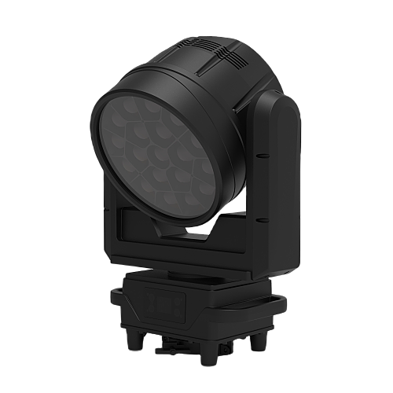


Instructions
Please read the instructions carefully before using the product and keep it properly.

1.Remove the packaging
Thank you for choosing to use our waterproof 19 head-shaking dyeing beam lamp. For the correct and safe use of this product, please read the instructions carefully before installing and using this product. This manual contains important installation and application information. When installing and operating the product, please strictly follow the operating steps in the manual. At the same time, please keep this manual properly.

The waterproof 19 head-shaking dyeing beam lamp of our company uses a new type of beautiful high temperature resistant engineering plastic shell and high hardness metal body. This product is designed and produced in strict accordance with the CE standard and conforms to the DMX512 signal protocol of the international standard. It can be used alone or online. It has the characteristics of fast rotation, low noise and powerful functions. It is suitable for small and medium-sized concerts, theatres, studios, nightclubs and bars.

This product uses 19 40 W 4-in-1 lamp beads with high brightness and stability. Please carefully remove the package, check whether the product is damaged during transportation after the package is removed, and check whether the following contents are complete.

Waterproof head-shaking dyeing lamp -- 1 set of signal line -- 1 set of signal line
Lock it up --
Power cord -- 1 lifting ring -- 1

2. Product Introduction

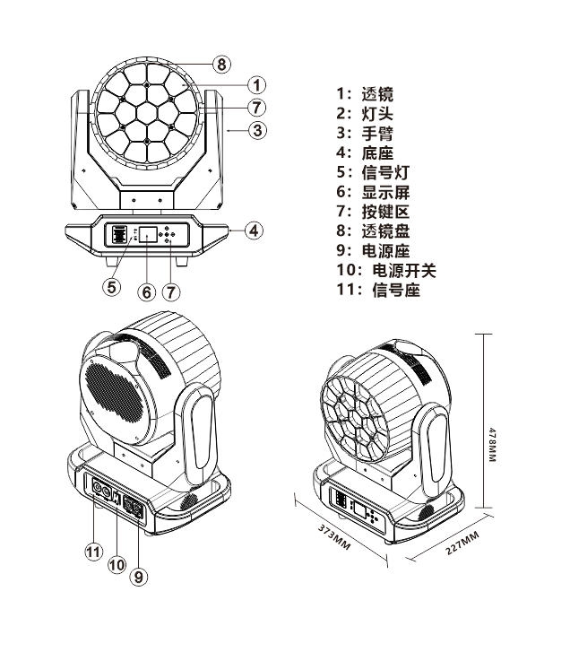
3. Safety instructions

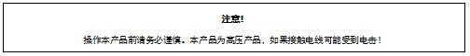
This product is in good condition before delivery. In order to keep the product in good condition and ensure safe operation, the user should follow the safety precautions and the warnings in this manual.
IMPORTANT: Damage caused by not following this instruction is not covered by warranty. The Supplier shall not be responsible for any product problems arising therefrom.
If the product has been exposed to extreme and unstable temperatures (e.g., after shipping), do not immediately connect the product to the power supply, as water droplets due to temperature changes may damage the product. Please use the product after it returns to normal temperature.
This product can be used in the voltage range of 90-240 V and is a product for indoor use. Please make sure that the ground voltage is not higher than the range that the product can bear! The power plug must be plugged into a Class I socket with good protection. The green or teal conductor must be grounded.
Always check the power cord for this product level. Make sure that the power cord is not folded or damaged, scratched, or connected to other cords! Pay special attention when connecting the power cord or related wiring. Always unplug the product when not in use or before cleaning.
Before using the product, please familiarize yourself with its operating functions. Please do not allow children or unprofessional personnel to touch the product.
Do not shake the product. Do not use brute force when installing or operating the product. Do not allow unprofessional personnel to operate the product. Most of the damage is due to unprofessional handling.
The product is not equipped with relevant maintenance accessories. The maintenance and repair of the product can only be carried out by professionals!
Please do not tamper with the product, otherwise it may be damaged and the resulting damage is not covered by the warranty. Moreover, unprofessional operation may cause short circuit, burn or electric shock, etc.

4. Operating instructions

This product is a head-shaking dyeing beam lamp, which is used to create the effect of dyeing performance.
-- If the product has experienced a large temperature difference (for example, after transportation), do not start the product immediately, because hot and cold shrinkage will damage the product. Please wait until the device reaches normal room temperature before starting the product.
-- Pay attention to earthquake prevention. Avoid strong collision during product installation.
-Please do not lift the entire product through the lamp head, as the mechanical properties of the device may be damaged.
-When choosing the installation site, please make sure that the product is not exposed to excessive heat, humidity or dust. Do not place any wires on the ground, or you may be exposed to the risk of electric shock.
-- Before installing the product, make sure that the installation point is secure
-Please attach the product to the safety rope and check whether all the screws are correct during installation.
-- Please make sure the lens is in good condition. When the lens is damaged or scratched, replace the lens.
-It is recommended that the product be operated by technicians who are familiar with the product. It is forbidden to operate this equipment by non-technical personnel, because many losses are the result of non-professional operation.
-Please keep the packing materials properly in case of secondary transportation.
-- Do not change the product without the guidance of the manufacturer or distributor.
--Any equipment failure caused by operating and using the equipment not in accordance with the instructions shall not be covered by the warranty. Moreover, any accidents caused by short circuit, injury, electric shock, ultraviolet rays, bulb explosion, etc. Are not covered by the warranty.

5. Product hanging and installation

Note: For greater safety, hang the product away from walkways, seating areas, or areas within easy reach.
Before hanging the product, please make sure that the mounting point can bear 10 times the weight of the product.
The product must be installed with a double protection device, such as a safety rope.
Do not stand under the mounting point when hanging, removing, or servicing the product
Please ensure that the product is installed at least 0.5 meters away from flammable materials.
Please remember to use the safety rope as a safety guarantee to prevent accidents when the lock is loosened.
Lifting point: The installation personnel must be experienced in the requirements of top hanging, including the calculation of load-bearing requirements, the installation materials used, and the periodic inspection of the safety conditions of the installation materials and products. If you lack this knowledge, do not attempt to install it yourself. If it is not operated correctly, it may cause serious consequences such as personal injury.
Make sure that all required hanging and installation steps are completed before the product is powered on.
Quick locking hanger: The bottom of this product has specially designed professional hangers, including quick locking hangers and safety rope hanging points (please refer to the figure below).
When hanging the product on the truss, please remember to use the appropriate quick lock, fix it to the quick lock hanger position of the product, and use the M10 screw to hang it. In order to further ensure safety, please install the safety rope at the hanging point of the safety rope at the bottom of the product and fix it on the truss. Regardless of the type of sling you choose, remember to use a safety rope. The bottom of the product is equipped with a special safety rope hanging point, please refer to the figure above, and please remember to use the special safety rope hanging point, do not install the safety rope in the handle position.

6. DMX-512 connectivity

Please insert the male of the XLR signal line equipped with this product into the signal output port of the controller, and insert the female into the signal input port on the rear plate of this product. You can connect multiple products in series, and the signal line needs to be three-core, shielded, with XLR input and output heads. Refer to the figure below.

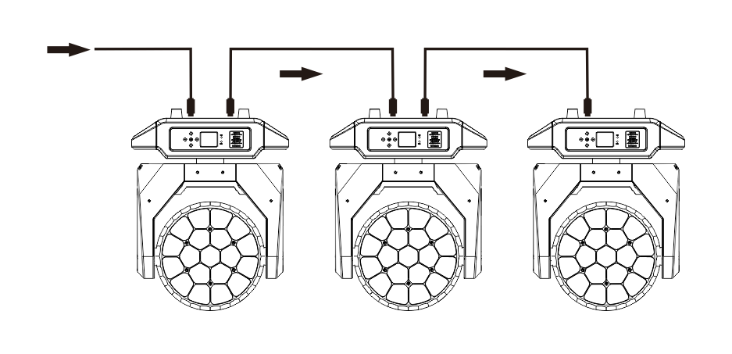
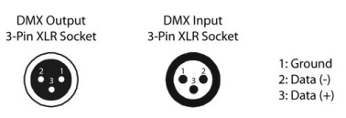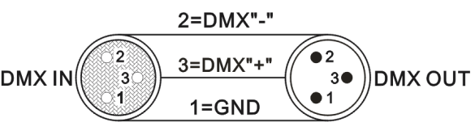

DMX-512 connection with terminator (loop connection)
In the installation process, if the signal line is laid for a long distance, or in the noisy environment of electrical appliances, such as dance halls, it is recommended to use DMX terminator (loop connection). This can avoid digital control signal turbidity caused by electrical noise. The DMX terminator consists of simple XLR connectors 2-core and 3-core connected to a 120 ohm resistor. Please plug the terminator into the XLR output port of the last product. Please refer to the figure below.

23 channel mode

Passageway | Function | DMX value | Description
1 | X-axis | 0-255 | 0-540 degrees
2 | X-axis fine adjustment | 0-255 | 16 bit adjustable
3 | Y-axis | 0-255 | 0-205 degrees
4 | Y-axis fine adjustment | 0-255 | 16 bit adjustable
5 | XY speed | 0-255 | Speed from fast to slow
6 | Focus | 0-255 | Angle from small to large
7 | Rotation | 0-127 | 0 ~ 60 degrees
7 | Rotation | 128-191 | Stepless smooth transition from fast to slow
7 | Rotation | 200-255 | Stepless reverse rotation from slow to fast
8 | Total dimming | 0-255 | Linear dimming from dark to light
9 | Strobe | 0-3 | Lights up
9 | Strobe | 4-255 | Synchronous stroboscopic speed from slow to fast (1HZ-25HZ)
10 | R Dimming | 0-255 | Linear dimming from dark to light
11 | G Dimming | 0-255 | Linear dimming from dark to light
12 | B Dimming | 0-255 | Linear dimming from dark to light
13 | W Dimming | 0-255 | Linear dimming from dark to light
14 | Color temperature | 0-255 | Linear color temperature adjustment
15 | Dyeing | 0-255 | Built-in color selection, 4 numbers for one color combination
16 | Static effect | 0-255 | Seven numbers, one effect.
17 | Dynamic effect | 0-255 | Three numbers, one effect.
18 | Dynamic effect speed | 0-255 | From slow to fast (with 15 channels)
19 | Background color R | 0-255 | Linear dimming from dark to light
20 | Background color G | 0-255 | Linear dimming from dark to light
21 | Background color B | 0-255 | Linear dimming from dark to light
22 | Background color W | 0-255 | Linear dimming from dark to light
23 | Reset | 0-250 | No function
23 | Reset | 251-255 | Resetting of lamp body is effective for 5S

25-channel mode

Passageway | Function | DMX value | Description
1 | X-axis | 0-255 | 0-540 degrees
2 | X-axis fine adjustment | 0-255 | 16 bit adjustable
3 | Y-axis | 0-255 | 0-205 degrees
4 | Y-axis fine adjustment | 0-255 | 16 bit adjustable
5 | XY speed | 0-255 | Speed from fast to slow
6 | Focus | 0-255 | Angle from small to large
7 | Rotation | 0-127 | 0 ~ 60 degrees
7 | Rotation | 128-191 | Stepless smooth transition from fast to slow
7 | Rotation | 200-255 | Stepless reverse rotation from slow to fast
8 | Total dimming | 0-255 | Linear dimming from dark to light
9 | Strobe | 0-3 | Lights up
9 | Strobe | 4-203 | Synchronous stroboscopic speed from slow to fast (1HZ-25HZ)
9 | Strobe | 204-255 | Random strobe
10 | R Dimming | 0-255 | Linear dimming from dark to light
11 | G Dimming | 0-255 | Linear dimming from dark to light
12 | B Dimming | 0-255 | Linear dimming from dark to light
13 | W Dimming | 0-255 | Linear dimming from dark to light
14 | Color temperature | 0-255 | Linear color temperature adjustment
15 | Dyeing | 0-255 | Built-in color selection, 4 numbers for one color combination
16 | The pattern is faded | 0-255 | The pattern effect is diluted
17 | Pattern translation | 0-255 | Pattern translation
18 | Static effect | 0-255 | Seven numbers, one effect.
19 | Dynamic effect | 0-255 | Three numbers, one effect.
20 | Dynamic effect speed | 0-255 | From slow to fast (with 15 channels)
21 | Background color R | 0-255 | Linear dimming from dark to light
22 | Background color G | 0-255 | Linear dimming from dark to light
23 | Background color B | 0-255 | Linear dimming from dark to light
24 | Background color W | 0-255 | Linear dimming from dark to light
25 | Reset | 0-250 | No function
25 | Reset | 251-255 | Resetting of lamp body is effective for 5S

Passageway | Function | DMX value | Description
1 | X-axis | 0-255 | 0-540 degrees
2 | X-axis fine adjustment | 0-255 | 16 bit adjustable
3 | Y-axis | 0-255 | 0-205 degrees
4 | Y-axis fine adjustment | 0-255 | 16 bit adjustable
5 | XY speed | 0-255 | Speed from fast to slow
6 | Focus | 0-255 | Angle from small to large
7 | Rotation | 0-127 | 0 ~ 60 degrees
8 | White fine adjustment | 128-191 | Stepless smooth transition from fast to slow
9 | Linear color temperature adjustment | 200-255 | Stepless reverse rotation from slow to fast
8 | Total dimming | 0-255 | Linear dimming from dark to light
9 | Strobe | 0-3 | Lights up
9 | Strobe | 4-203 | Synchronous stroboscopic speed from slow to fast (1HZ-25HZ)
9 | Strobe | 204-255 | Random strobe
10 | R Dimming | 0-255 | Linear dimming from dark to light
11 | G Dimming | 0-255 | Linear dimming from dark to light
12 | B Dimming | 0-255 | Linear dimming from dark to light
13 | W Dimming | 0-255 | Linear dimming from dark to light
14 | Color temperature | 0-255 | Linear color temperature adjustment
15 | Dyeing | 0-255 | Built-in color selection, 4 numbers for one color combination
16 | Static effect | 0-255 | Seven numbers, one effect.
17  18 | Dynamic effect  Dynamic effect speed | 0-255 | Three numbers, one effect.
17  18 | Dynamic effect  Dynamic effect speed | 0-255 | From slow to fast (with 15 channels)
19 | Background color R | 0-255 | Linear dimming from dark to light
20  21  22 | Background color G  Background color B  Background color W | 0-255 | Linear dimming from dark to light
20  21  22 | Background color G  Background color B  Background color W | 0-255 | Linear dimming from dark to light
20  21  22 | Background color G  Background color B  Background color W | 0-255 | Linear dimming from dark to light
23 | Reset | 0-250 | No function
23 | Pattern effect speed | 251-255 | Resetting of lamp body is effective for 5S

101 channel mode

Passageway | Function | DMX value | Description
1 | X-axis | 0-255 | 0-540 degrees
2 | X-axis fine adjustment | 0-255 | 16 bit adjustable
3 | Y-axis | 0-255 | 0-205 degrees
4 | Y-axis fine adjustment | 0-255 | 16 bit adjustable
5 | XY speed | 0-255 | Speed from fast to slow
6 | Focus | 0-255 | Angle from small to large
7 | Rotation | 0-127 | 0 ~ 60 degrees
7 | Rotation | 128-191 | Stepless smooth transition from fast to slow
7 | Rotation | 200-255 | Stepless reverse rotation from slow to fast
8 | Total dimming | 0-255 | Linear dimming from dark to light
9 | Strobe | 0-3 | Lights up
9 | Strobe | 4-203 | Synchronous stroboscopic speed from slow to fast (1HZ-25HZ)
9 | Strobe | 204-255 | Random strobe
10 | R Dimming | 0-255 | Linear dimming from dark to light
11 | G Dimming | 0-255 | Linear dimming from dark to light
12 | B Dimming | 0-255 | Linear dimming from dark to light
13 | W Dimming | 0-255 | Linear dimming from dark to light
14 | Color temperature | 0-255 | Linear color temperature adjustment
15 | Dyeing | 0-255 | Built-in color selection, 4 numbers for one color combination
16 | The pattern is faded | 0-255 | The pattern effect is diluted
17 | Pattern translation | 0-255 | Pattern translation
18 | Static effect | 0-255 | Seven numbers, one effect.
19 | Dynamic effect | 0-255 | Three numbers, one effect.
20 | Dynamic effect speed | 0-255 | From slow to fast (with 15 channels)
21 | Background color R | 0-255 | Linear dimming from dark to light
22 | Background color G | 0-255 | Linear dimming from dark to light
23 | Background color B | 0-255 | Linear dimming from dark to light
24 | Background color W | 0-255 | Linear dimming from dark to light
25 | Reset | 0-250 | No function
25 | Reset | 251-255 | Resetting of lamp body is effective for 5S

Passageway | Function | DMX value | Description
26 | R1 LED dimming | 0-255 | Linear dimming from dark to light
27 | G1 LED dimming | 0-255 | Linear dimming from dark to light
28 | B1 LED dimming | 0-255 | Linear dimming from dark to light
29 | W1 LED dimming | 0-255 | Linear dimming from dark to light
… | ………… | ………… | …………
98 | R1 LED dimming | 0-255 | Linear dimming from dark to light
99 | G1 LED dimming | 0-255 | Linear dimming from dark to light
100 | B1 LED dimming | 0-255 | Linear dimming from dark to light
101 | W1 LED dimming | 0-255 | Linear dimming from dark to light

8.Menu diagram

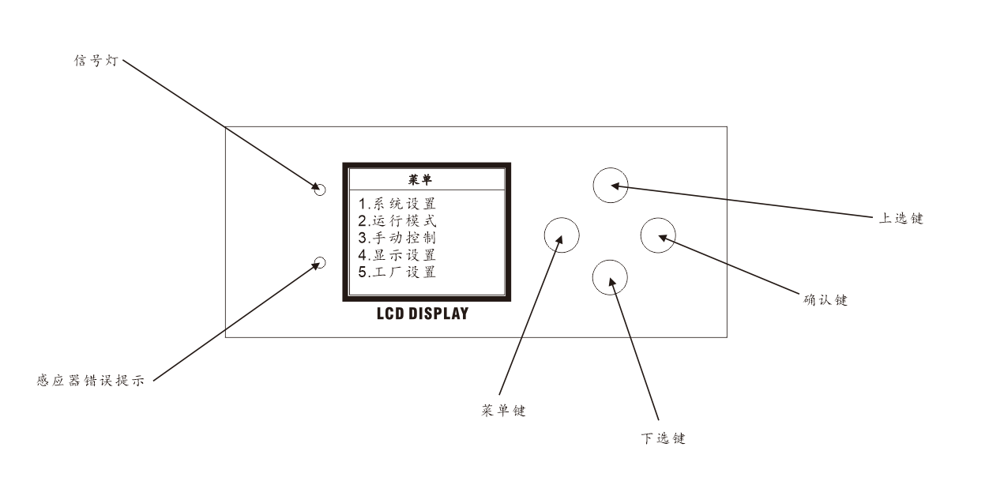

Menu description
1 System settings
1. Confirm the modification of DMX address 002 by pressing the Enter key, press the Up/Down key to select the DMX address, confirm again, and return to exit.
2. When the encoder is closed, confirm the modification through the confirmation key, and then select Close/Open up and down, confirm again, and return to exit.
3. X Reverse Close Confirm the modification with the confirmation key, and then select Close/Open up and down, confirm again, and return to exit.
4. Y Reversal Close Confirm the modification with the confirmation key, and then select Close/Open up and down, confirm again, and return to exit.
2 Operation mode
The operating mode DMX can be modified by pressing the Enter key. Press the Up/Down key to select the operating mode, and then press the Enter key to confirm and return to exit.
Channel selection 23CH/25CH/101CH
3 Manual setting
1X****** 000
2X Fine adjustment * * * * * 000
3Y****** 000
4Y fine adjustment * * * * * 000
5 XY speed * * * * * 000
6 Focus * * * * * 000
7 rotating mirror * * * * * 000
8 Dimming * * * * * 000
9 Strobe * * * * * 000
10 Foreground Red * * * * * 000
11 Foreground Green * * * * * 000
12 foreground blue * * * * * 000
13 Foreground white * * * * * 000
14 Color temperature * * * * * 000
15 Stain * * * * * 000
16 Fade * * * * * 000
17 Pattern * * * * * 000
19 Gif * * * * * 000
20 Speed * * * * * 000
21 Background Red * * * * * 000
22 Background green * * * * * 000
23 Background blue * * * * * 000
24 Background white * * * * * 000
25 Reset * * * * * 000
3 Explicit setting
1. Select the Chinese language, confirm the modification by pressing the confirmation key, select the language by pressing the up and down keys, confirm again, and return to exit.
2. Turn off the reverse display setting, confirm the modification by pressing the confirmation key, press the up and down keys to open, confirm again, and return to exit.
3. When the backlight setting is turned off, confirm the modification by pressing the confirmation key, press the up and down keys to turn it on, confirm again, and return to exit.
4 Software version-088B
5 Factory settings (password 138)
Calibration
1X Calibration128 Confirm the modification by pressing the Enter key, then select the appropriate channel value up and down, confirm again, and return to exit
2Y Calibration 128 Confirm the modification by pressing the Enter key, select the appropriate channel value up and down, confirm again, and return to exit.
3 Focus 128 Confirm the modification through the confirmation key, then select the appropriate channel value up and down, confirm again, and return to exit.
4 Red 220 Confirm the modification through the confirmation key, then select the appropriate channel value up and down, confirm again, and return to exit.
5 Green 220 Confirm the modification through the confirmation key, then select the appropriate channel value up and down, confirm again, and return to exit.
6 Blue 220 Confirm the modification through the confirmation key, then select the appropriate channel value up and down, confirm again, and return to exit.
7 White 220 Confirm the modification through the confirmation key, then select the appropriate channel value up and down, confirm again, and return to exit.
8LOGO 000 Confirm first through the left function key, then select the appropriate LOGO up and down, confirm again, and return to exit
9. Confirm the modification of current 004 through the confirmation key, select the appropriate channel value up and down, confirm again, and return to exit.
10 Speed 004 Confirm the modification through the confirmation key, then select the appropriate channel value up and down, confirm again, and return to exit.
11. When the fan is closed, confirm the modification with the confirmation key, and then select the appropriate channel value up and down, confirm again, and return to exit.
12 Temperature 65 Confirm the modification through the confirmation key, then select the appropriate channel value up and down, confirm again, and return to exit.
13 Temperature-Fan off Confirm the modification with the confirmation key, select the appropriate channel value up and down, confirm again, and return to exit.

9.Lumen value

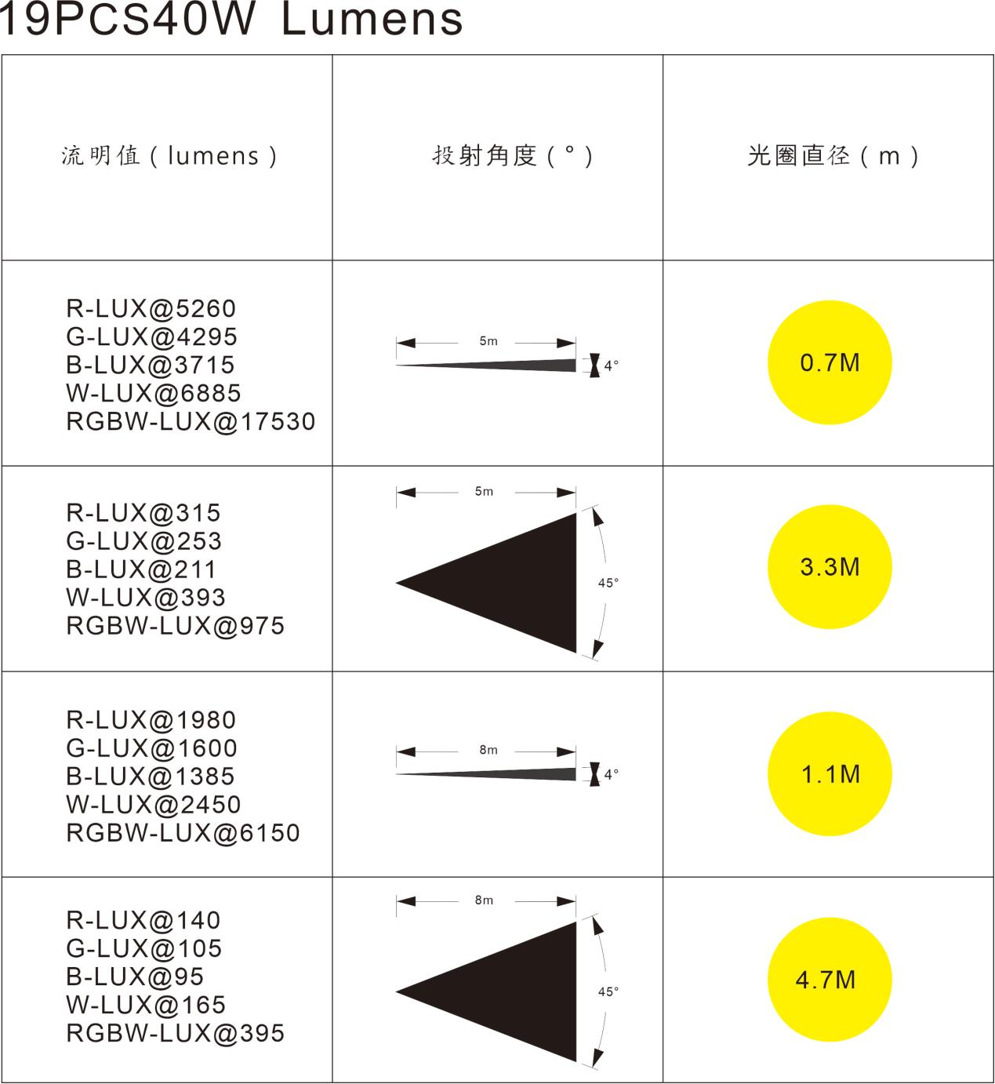
10. Product characteristics
Input voltage: AC100-240V 50/60HZ
Maximum power: 1200 W
Beam divergence angle: 4-45 degrees
DMX channels: 23/25/101 channels
Light source: 19 four-in-one (Tianxin 40W)
Control mode: master-slave synchronization, stand-alone, voice control
Signal input: standard three-core signal socket input and output
Lens rotation angle: 360 °
Horizontal scan: X-axis: 540 °
Vertical scan: Y axis: 270 °
Grade: IP65
Net weight: 22 KG
Characteristic
- Each lamp bead can be controlled individually.
- The unique honeycomb design of the lens can be infinitely rotated to bring a variety of fantastic effects.
- The display automatically rotates 180 ° to accommodate different mounting angles.
- It integrates light beam, dyeing, effect and other uses.
- Scan position memory function with automatic reset.
- With the functions of fan cooling and automatic temperature detection, the system will automatically stop working to protect the lamp when it detects that the temperature is too high.
- Address code setting: the built-in long-life battery can be charged automatically, and the lamp power supply does not need to be connected when setting the address code (optional)

11. Product maintenance and cleaning

Please pay attention to the following points when testing this product:
- All screws and parts for installing the product must be tightly connected without rust.
- The shell, lens, fixed parts and installation site (such as ceiling, hanger, truss, etc.) shall not be deformed.
- Mechanical moving parts shall be free of wear and unbalanced rotation.
- The power cord shall be free of any damage, material damage or scar, etc.
The installation and use of the product must be carried out by trained professional technicians to ensure that potential safety hazards are eliminated.

In order to maintain the product in good condition and prolong its service life, we recommend regular cleaning of the product.
1. Clean the outer lens and inner lens of the product every week to prevent the light output of the product from being reduced due to dust accumulation on the lens.
2. Clean the fan every week.
3. Every three months, a professional electrical engineer will conduct a detailed circuit inspection of the product to ensure that the circuit contacts are in good condition, so as to prevent the aging of the circuit contacts due to overheating.
We recommend that the product should be cleaned regularly, please be careful not to use damp or linen, and never use alcohol or solvents for cleaning.
This product is not equipped with replacement parts. Please refer to the Installation Instructions section.
If you need any spare parts, please purchase them from your local dealer.

